*Long Description:*

A natural product from the highlands of the Himalayas full of beneficial extracts of sea buckthorn, cranberry and Vitamin C. Sea Buckthorn Gummies are suitable for vegetarians, as the product does not contain animal gelatin.

The balanced content of highly concentrated extracts of sea buckthorn and cranberry has many benefits for the human body:

• Supports the proper functioning of the immune system

• Has a positive effect on heart health and the cardiovascular system

• It has antioxidant effects and has a positive effect on the overall condition of the body

• Helps reduce fatigue and exhaustion

• Supports proper digestive function

*Short Description:*Healthy sweets from the highlands of the Himalayas to support immunity. High in Vitamin C and other nutrients.

|  |  |
| --- | --- |
| *Logistics:* | |
| EAN | 8594193242085 |
| Content | 60 gummies |
| Weight (kg) | 0,16 |
| Height (mm) | 119 |
| Width (mm) | 73 |
| Depth (mm) | 73 |
| Pieces per carton | 15 |
| Pieces per pallet | 1080 |
| Customs code | 2106 90 98 |

**HIMALYO YETTI SEA BUCKTHORN gummies**

*Differentiation vs. common sea buckthorn products:*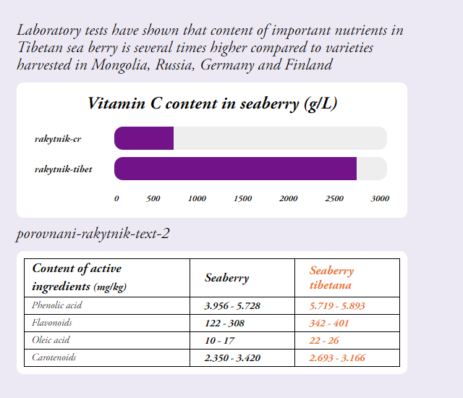

Tibet sea buckthorn – European sea buckthorn

1. Also other important nutrients had significantly higher values in Tibetan sea buckthorn when compared to European variety of sea buckthorn

--- a prosim zmenit v tabulce seaberry na sea buckthorn

*Warning:*Not intended for children under 3 years. Dietary supplements are not intended as a substitute for a varied and balanced diet. Do not exceed the recommended daily dosage!

Store in a dry place, out of direct sunlight, at a temperature of 10-25 ° C.

*Recommended dosage:*Adults - 2 gummy candies twice a day, Children from 3 years - 1 gummy candy twice a day

*Ingredients:*

1 sea buckthorn gummy candy (3g): 150 mg extract from the fruit of the Tibetan sea buckthorn (Hippophae tibetana), Vitamin C - L-ascorbic acid (95 mg, i.e. 118.7% RDI *); 1 sea buckthorn gummy candy (2g): 85 mg extract from the seed of the Tibetan sea buckthorn (Hippophae tibetana); 1 cranberry gummy candy (2g): 50 mg cranberry fruit extract (Vaccinium vitis-idaea); other ingredients: malt syrup, sugar, glucose, emulsifier: pectin, acidity regulator: sodium citrate and citric acid, coconut oil. 60 gummy candies.

*Main Claims for online marketing:*

* Vitamins for strong immunity of your children
* Natural support of immunity
* Natural vegan sea buckthorn gummy candies with high content of Vitamin C

*Benefits:*

The Tibetan sea buckthorn is generally classified among the superfoods. This is not a fixed classification, but superfoods are generally understood as a nutritionally rich foods full of vitamins, minerals, fiber, antioxidants and nutrients of plant origin.

The name of this super berry comes from the ancient Greek word Hippophae, which means glittering horse. The ancient Greeks already discovered the beneficial effects of sea buckthorn, as horses grazing in areas with its high incidence were healthy, well built, and had shiny coats of hair.

**Ayurvedic and Tibetan Medicine**

The original sea buckthorn variety has been used in Ayurvedic and Tibetan medicine for thousands of years and is often called the plant of the future. Sea buckthorn fruits have always been widely used in the Himalayan region, especially to support immunity, for proper digestion and to suppress feelings of fatigue and exhaustion.

**Contemporary Medicine**

Modern medicine increasingly uses this beneficial plant, as sea buckthorn supports the immune system. In addition, regular use of sea buckthorn contributes to the normal function of the skin, cardiovascular system, digestive system and the prostate.

Sea buckthorn is widely used in cosmetics, where sea buckthorn oil, which is pressed either from the fruits or seeds of the sea buckthorn, is primarily used. A clinical study conducted at the University of Turku in Finland in 1999 found that sea buckthorn oil contributes to the good health of the skin and a healthy skin appearance within four months of its use as a dietary supplement. A Puredia case study in 2017 documented the effects of a two-week application of sea buckthorn oil on postoperative scars.

*Categories:*Dietary Supplement. Immunity, immunity for children, Vitamin C, heart health, cardiovascular health, antioxidants, healing, natural stimulant, mental health, digestive tract, vegan

*Target distribution:*

*Online pharmacies, brick and mortar pharmacies, healthy food stores, organic/bio stores, drug stores – healthy diet*

*Target customer:*Mothers 25-45