*Categories:*Food product. Vitality and energy, detox, antioxidants, longevity, metabolism support, diet, weight control, superfood, gluten free, vegan, raw, bio

*Ingredients: 100% pure squeezed organic juice of goji berries (Lycium Chinense). 750/350 ml*

*Long Description:*

The juice is carefully cold-pressed, using exclusively fresh, hand-picked fruits of Lycium Chinense, which, thanks to their Alpine origin and demanding climatic conditions, contain a unique concentration of nutrients.

The authentic color and natural layering at the top of the bottle indicate that the juice is indeed a natural, organic product, in the processing of which no preservatives, thickeners, or other additives have been used. It is characterized by an unmistakable distinctive color, and, above all, by its premium taste and aroma.

For 5,000 years, traditional Chinese medicine has considered GOJI to be an “elixir of youth, longevity and beauty.” Thanks to its high content of nutrients, it is enough to regularly consume only 25 ml of juice per day to achieve optimal results.

Goji juice is suitable for the whole family. It can be consumed by children from 3 years of age.

*Short Description:*An elixir of youth, longevity and beauty – a purely natural juice from the berries of Lycium Chinense. Without dilution or preservatives.

|  |  |
| --- | --- |
| *Logistics:* | |
| EAN | 8594193241019 |
| Content | 750 ml |
| Weight (kg) | 1.2 |
| Height (mm) | 310 |
| Width (mm) | 75 |
| Depth (mm) | 75 |
| Pieces per carton | 6 |
| Pieces per pallet | 600 |
| Customs code | 2009 89 99 |

**HIMALYO GOJI 100% Juice BIO**

*Articles:*- GOJI_detox  
- GOJI_juice  
- GOJI_beauty and health

*Warning:*Store at room temperature away from direct sunlight. Once opened, do not store above 5 °C and consume within 30 days.Do not consume directly from the bottle. The stratification of the juice when the contents of the bottle settle is a natural phenomenon, not a defect.

*Recommended dosage:*25 ml of juice per day.

*Benefits:*

The goji berry is generally classified among the superfoods. This is not a fixed classification, but superfoods are generally understood as nutritionally rich foods full of vitamins, minerals, fiber, antioxidants and nutrients of plant origin.

**Traditional Chinese Medicine**

In traditional Chinese medicine, goji berry fruits have been used primarily as a tonic to prolong life. In the Himalayas, Goji has long been called the "fruit of longevity," the "fruit of immortality," or the "secret of beauty and eternal youth."

The highest quality of goji fruits, which are recognized by their typically sweet taste, can be found mainly in China and Mongolia, where they are also widely consumed and are an integral part of the diet. In these areas, the original inhabitants live to an old age and are known to possess amazing energy levels, even in the late years of their lives.

Countless clinical studies have researched the effects of goji on the human body. For example, between 2008 and 2009, a total of five randomized trials were conducted in the United States documenting the effect on the subjective status of patients receiving goji juice versus a placebo control group. Patients were given an amount of juice corresponding to 150 g of fresh fruit for 14 days. The study researched the subjective feeling of well-being in the absence of any side effects.

*Clinical studies:***ORAC** (Oxygen Radical Absorbance Capacity)

This is a standardised test designed to measure the effects of antioxidants in foods, which protect the human body from oxidative stress.

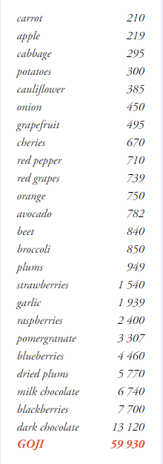

*Main Claims for online marketing:*

* For vitality and longevity
* Elixir of youth and vitality
* Healthy diet and weight control

*Target distribution:*

*Online pharmacies, brick and mortar pharmacies, healthy food stores, organic/bio stores, grocery stores – healthy diet section, drug stores – healthy diet*

*Target customer:*Women 35-50

Seniors 65+

Další varianty:

|  |  |
| --- | --- |
| *Logistika:* | |
| EAN | 8594193241187 |
| Content | 350 ml |
| Weight (kg) | 0,6 |
| Height (mm) | 230 |
| Width (mm) | 60 |
| Depth (mm) | 60 |
| Pieces per carton | 6 |
| Pieces per pallet | 1080 |
| Customs code | 2009 89 99 |