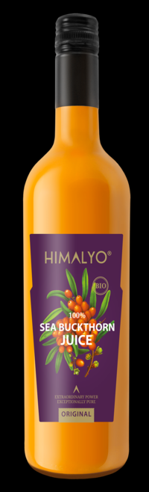
Long Description:
The cold-pressed juice is made exclusively from the fruits of the original alpine variety of Tibetan sea buckthorn. Hand-picked, ripe fruits guarantee an extremely high content of nutrients.
Sea buckthorn juice has a very specific taste and aroma, which may seem off-putting at first. Although the Tibetan sea buckthorn tastes more pleasant than common varieties of sea buckthorn and many consumers enjoy its taste, it is important to take into account that it may not appeal to your taste buds. In this case, we offer practical alternatives in the form of sea buckthorn capsules and oil.
• Contributes to the proper functioning of the immune systém
• Has a positive effect on heart health
• Supports the proper functioning of the digestive tract
• Has a positive effect on skin health
• Is an important antioxidant
Sea buckthorn juice is suitable for the whole family, it can be consumed by children from 3 years of age.

Ingredients: 100% pure squeezed organic Tibetan sea buckthorn juice. 750/350 ml

Categories:
Food product. Immunity, Vitamin C, heart health, cardiovascular health, antioxidants, healing, natural stimulant, mental health, digestive tract, skin health, superfood, gluten free, vegan, raw, bio

Short Description:
Elixir for immunity– a purely natural juice from the alpine variety of the Tibetan sea buckthorn. Without dilution or preservatives.

Logistics:
EAN | 8594193242016
Content | 750 ml
Weight (kg) | 1,2
Height (mm) | 310
Width (mm) | 75
Depth (mm) | 75
Pieces per carton | 6
Pieces per pallet | 600
Customs code | 2009 89 99

HIMALYO SEA BUCKTHORN 100% Juice BIO
Articles:
- Sea buckthorn immunity
- Tibetan sea buckthorn

Benefits:
The Tibetan sea buckthorn is generally classified among the superfoods. This is not a fixed classification, but superfoods are generally understood as a nutritionally rich foods full of vitamins, minerals, fiber, antioxidants and nutrients of plant origin.
The name of this super berry comes from the ancient Greek word Hippophae, which means glittering horse. The ancient Greeks already discovered the beneficial effects of sea buckthorn, as horses grazing in areas with its high incidence were healthy, well built, and had shiny coats of hair.
Ayurvedic and Tibetan Medicine
The original sea buckthorn variety has been used in Ayurvedic and Tibetan medicine for thousands of years and is often called the plant of the future. Sea buckthorn fruits have always been widely used in the Himalayan region, especially to support immunity, for proper digestion and to suppress feelings of fatigue and exhaustion.
Contemporary Medicine
Modern medicine increasingly uses this beneficial plant, as sea buckthorn supports the immune system. In addition, regular use of sea buckthorn contributes to the normal function of the skin, cardiovascular system, digestive system and the prostate.
Sea buckthorn is widely used in cosmetics, where sea buckthorn oil, which is pressed either from the fruits or seeds of the sea buckthorn, is primarily used. A clinical study conducted at the University of Turku in Finland in 1999 found that sea buckthorn oil contributes to the good health of the skin and a healthy skin appearance within four months of its use as a dietary supplement. A Puredia case study in 2017 documented the effects of a two-week application of sea buckthorn oil on postoperative scars.

Differentiation vs. common sea buckthorn products:
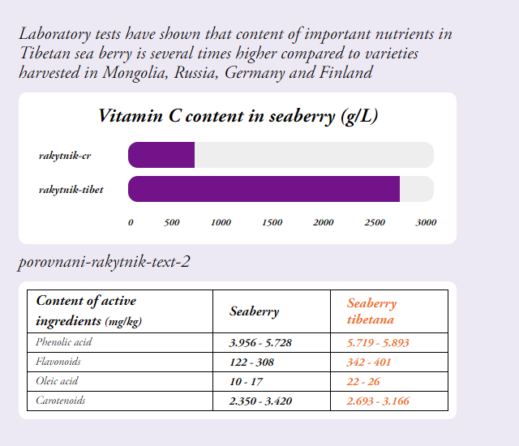

Tibet sea buckthorn – European sea buckthorn

- Also other important nutrients had significantly higher values in Tibetan sea buckthorn when compared to European variety of sea buckthorn
--- a prosim zmenit v tabulce seaberry na sea buckthorn
Warning:
Store at room temperature away from direct sunlight. Once opened, do not store above 5 °C and consume within 30 days. Do not consume directly from the bottle. The stratification of the juice when the contents of the bottle settle is a natural phenomenon, not a defect.
For a better taste sensation, we recommend mixing with water or fruit juice, or adding to a smoothie.
Recommended dosage:
25 ml of juice per day.

Main Claims for online marketing:
- Natural support of immunity
- For strong immunity
- 100% Tibetan sea buckthorn with high content of Vitamin C
Target distribution:
Online pharmacies, brick and mortar pharmacies, healthy food stores, organic/bio stores, grocery stores – healthy diet section, drug stores – healthy diet

Target customer:
Women 35-50

Další varianty:
Logistika:
EAN | 8594193241187
Content | 350 ml
Weight (kg) | 0,6
Height (mm) | 230
Width (mm) | 60
Depth (mm) | 60
Pieces per carton | 6
Pieces per pallet | 1080
Customs code | 2009 89 99

