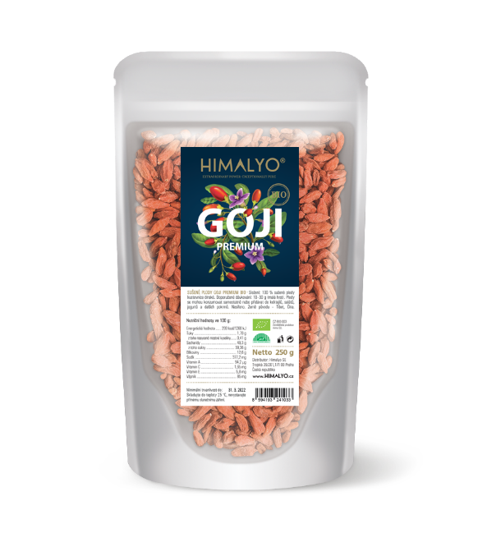
Long Description:
The fruits of HIMALYO GOJI PREMIUM are harvested on the Tibetan Plateau, where they are exposed to intense sun and harsh forces of nature. Like most crops that ripen at high altitudes and in clean environments, they boast unique strength and a high concentration of nutrients. They are thus completely unique and have no competition among commonly available fruits.
They are visibly bigger, sweeter and more nutritious.
The fruits are sulphur-free and in their pure natural form.
In traditional Chinese medicine, goji fruits have been long used primarily as a tonic to prolong life. In the Himalayas, goji has long been called the "fruit of longevity," the "fruit of immortality," or "the secret of beauty and eternal youth."

Ingredients: 100% organic dried fruits of Lycium Chinense. 100/250/500 g.

Categories:
Food Product. Vitality and energy, detox, antioxidants, longevity, metabolism support, diet, weight control, superfood, gluten free, vegan, raw, bio

Short Description:
Large and tasty dried fruits of Lycium Chinense grown in the pristine environment of the Tibetan plateau.

Logistics:
EAN | 8594193241033
Content | 250 g
Weight (kg) | 0,3
Height (mm) | 240
Width (mm) | 170
Depth (mm) | 60
Pieces per carton | 36
Pieces per pallet | 1152
Customs code | 0813 40 95

HIMALYO GOJI Dried Fruits BIO
Articles:
- GOJI_detox
- GOJI_beauty and health

Warning:
Store up to 25 °C, do not expose to direct sunlight.
Recommended dosage:
30 g (2 handfuls) of dried fruit per day.
Benefits:
The goji berry is generally classified among the superfoods. This is not a fixed classification, but superfoods are generally understood as nutritionally rich foods full of vitamins, minerals, fiber, antioxidants and nutrients of plant origin.
Traditional Chinese Medicine
In traditional Chinese medicine, goji berry fruits have been used primarily as a tonic to prolong life. In the Himalayas, Goji has long been called the "fruit of longevity," the "fruit of immortality," or the "secret of beauty and eternal youth."
The highest quality of goji fruits, which are recognized by their typically sweet taste, can be found mainly in China and Mongolia, where they are also widely consumed and are an integral part of the diet. In these areas, the original inhabitants live to an old age and are known to possess amazing energy levels, even in the late years of their lives.
Countless clinical studies have researched the effects of goji on the human body. For example, between 2008 and 2009, a total of five randomized trials were conducted in the United States documenting the effect on the subjective status of patients receiving goji juice versus a placebo control group. Patients were given an amount of juice corresponding to 150 g of fresh fruit for 14 days. The study researched the subjective feeling of well-being in the absence of any side effects.

Clinical studies:
ORAC (Oxygen Radical Absorbance Capacity)
This is a standardised test designed to measure the effects of antioxidants in foods, which protect the human body from oxidative stress.
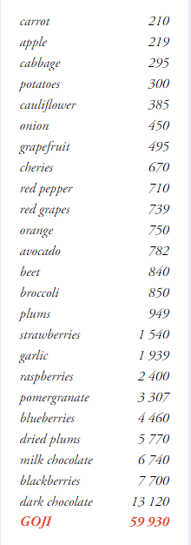

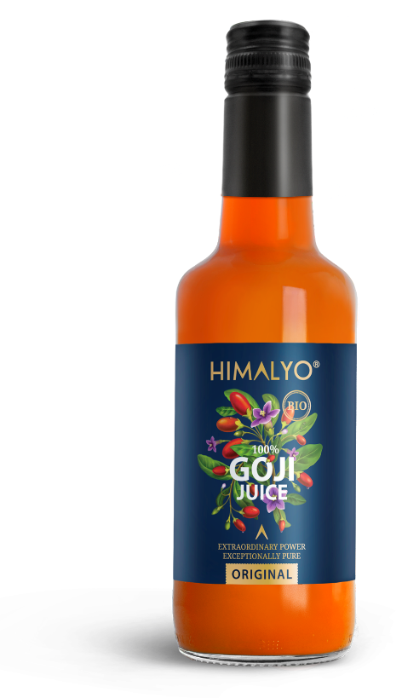
Main Claims for online marketing:
- Healthy diet and weight control
- For vitality and longevity
- Superfood

Target distribution:
Online pharmacies, brick and mortar pharmacies, healthy food stores, grocery stores, organic/bio food stores, drug stores – healthy diet

Target customer:
Women 35-50

Další varianty:
Logistika:
EAN | 8594193241187
Content | 350 ml
Weight (kg) | 0,6
Height (mm) | 230
Width (mm) | 60
Depth (mm) | 60
Pieces per carton | 6
Pieces per pallet | 1080
Customs code | 2009 89 99

