*Long Description:*

The purest essence and top product of Lycium Chinense is oil, gently extracted from the seeds of its fruits. This very costly and demanding production process yields a highly concentrated cocktail of beneficial ingredients, in perfectly balanced proportions, with a diverse variety of potential uses. As many as thirty goji fruits are needed for a single drop of this oil.

In traditional Chinese medicine, goji fruits have been long used primarily as a tonic to prolong life. In the Himalayas, goji has long been called the "fruit of longevity," the "fruit of immortality," or "the secret of beauty and eternal youth."

**Information on the Recommended Daily Dosage**

Goji seed oil is also widely used in cosmetics.

**Tips for use:**

• Gently massage into skin using circular motions.

• Add a few drops to your cream or face mask, to your compresses, wraps or hot bath.

*Ingredients:* 100% organic oil from the seeds of the goji fruit (Lycium Chinense). 30 ml.

*Categories:*Dietary Supplement. Vitality and energy, detox, antioxidants, longevity, metabolism support, diet, weight control, superfood, gluten free, vegan, raw, bio

*Short Description:*A pure natural oil from the seeds of Lycium Chinense, grown in the alpine environment of Tibet

|  |  |
| --- | --- |
| *Logistics:* | |
| EAN | 8594193241163 |
| Content | 30 ml |
| Weight (kg) | 0,1 |
| Height (mm) | 120 |
| Width (mm) | 50 |
| Depth (mm) | 35 |
| Pieces per carton | 30 |
| Pieces per pallet | 1800 |
| Customs code | 1515 90 59 |

**HIMALYO GOJI 100% Seed oil BIO**

*Articles:*- GOJI_detox  
- GOJI_beauty and health

*Warning:*Not intended for children under 3 years. Dietary supplements are not intended to be used as a substitute for a balanced diet. Do not exceed the recommended daily dosage!

Store at room temperature away from direct sunlight. Keep out of reach of children.

*Recommended dosage:*Adults 2-7 drops 1-3 times a day, Children from 3 years 1-3 drops a day (7 drops = 0.35 ml)

*Benefits:*

The goji berry is generally classified among the superfoods. This is not a fixed classification, but superfoods are generally understood as nutritionally rich foods full of vitamins, minerals, fiber, antioxidants and nutrients of plant origin.

**Traditional Chinese Medicine**

In traditional Chinese medicine, goji berry fruits have been used primarily as a tonic to prolong life. In the Himalayas, Goji has long been called the "fruit of longevity," the "fruit of immortality," or the "secret of beauty and eternal youth."

The highest quality of goji fruits, which are recognized by their typically sweet taste, can be found mainly in China and Mongolia, where they are also widely consumed and are an integral part of the diet. In these areas, the original inhabitants live to an old age and are known to possess amazing energy levels, even in the late years of their lives.

Countless clinical studies have researched the effects of goji on the human body. For example, between 2008 and 2009, a total of five randomized trials were conducted in the United States documenting the effect on the subjective status of patients receiving goji juice versus a placebo control group. Patients were given an amount of juice corresponding to 150 g of fresh fruit for 14 days. The study researched the subjective feeling of well-being in the absence of any side effects.

*Clinical studies:***ORAC** (Oxygen Radical Absorbance Capacity)

This is a standardised test designed to measure the effects of antioxidants in foods, which protect the human body from oxidative stress.

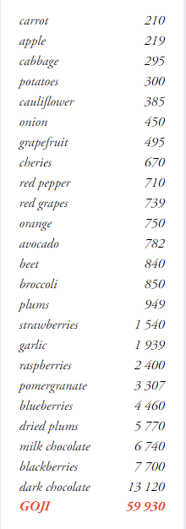

*Main Claims for online marketing:*

* For vitality and longevity
* Elixir of youth and vitality
* Slows the aging process of your skin

*Target distribution:*

*Online pharmacies, brick and mortar pharmacies, healthy food stores, organic/bio drug stores, drug stores – healthy diet*

*Target customer:*Women 35-50

Další varianty:

|  |  |
| --- | --- |
| *Logistika:* | |
| EAN | 8594193241187 |
| Content | 350 ml |
| Weight (kg) | 0,6 |
| Height (mm) | 230 |
| Width (mm) | 60 |
| Depth (mm) | 60 |
| Pieces per carton | 6 |
| Pieces per pallet | 1080 |
| Customs code | 2009 89 99 |