*Long Description:*

The pure essence and the top product of sea buckthorn is oil obtained by gentle extraction from the seeds of its fruits. A very demanding and expensive production process brings a highly concentrated cocktail of active ingredients. Up to thirty fresh sea buckthorn fruits are consumed in a single drop of this oil. It is an alternative to using sea buckthorn juice.

• Contributes to the proper functioning of the immune system

• Has a positive effect on heart health

• Supports the proper functioning of the digestive tract

• Has a positive effect on skin health

**Information on the Recommended Daily Dosage**

Advantageous benefits of external use:

Sea buckthorn oil is also widely used in cosmetics. For example, the 2017 Puredia case study documented the effects of a two-week application of sea buckthorn oil on postoperative scars.

Sea buckthorn seed oil is colorless and can therefore be used in more visible places.

**Tips for use:**

• Gently massage into skin using circular motions.

• Add a few drops to your cream, or face mask, to your compresses, wraps or hot bath.

*Short Description:*Pure natural oil from the seeds of the fruits of the alpine variety of Tibetan sea buckthorn

|  |  |
| --- | --- |
| *Logistics:* | |
| EAN | 8594193242030 |
| Content | 30 ml |
| Weight (kg) | 0,1 |
| Height (mm) | 120 |
| Width (mm) | 50 |
| Depth (mm) | 35 |
| Pieces per carton | 30 |
| Pieces per pallet | 1800 |
| Customs code | 1515 90 59 |

**HIMALYO SEA BUCKTHORN 100% Seed oil BIO**

*Differentiation vs. common sea buckthorn products:*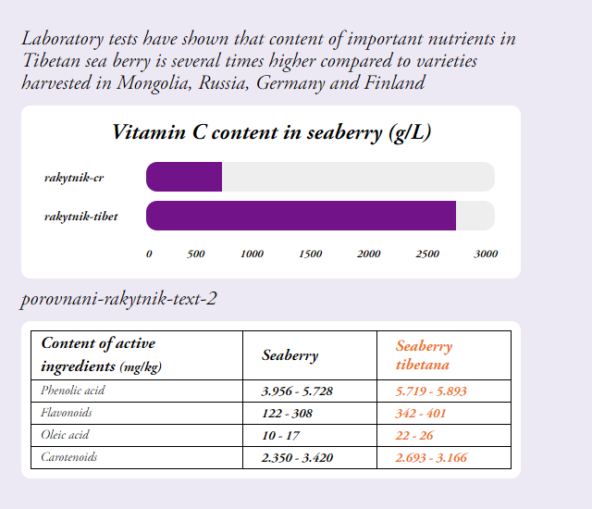

Tibet sea buckthorn – European sea buckthorn

1. Also other important nutrients had significantly higher values in Tibetan sea buckthorn when compared to European variety of sea buckthorn

--- a prosim zmenit v tabulce seaberry na sea buckthorn

*Warning:*Not intended for children under 3 years. Dietary supplements are not intended to be used as a substitute for a balanced diet. Do not exceed the recommended daily dosage! Store at room temperature away from direct sunlight. Keep out of reach of children.

*Recommended dosage:*For adults 2-7 drops 1-3 times a day, for children from 3 years 1-3 drops a day (7 drops = 0.35 ml)

*Benefits:*

The Tibetan sea buckthorn is generally classified among the superfoods. This is not a fixed classification, but superfoods are generally understood as a nutritionally rich foods full of vitamins, minerals, fiber, antioxidants and nutrients of plant origin.

The name of this super berry comes from the ancient Greek word Hippophae, which means glittering horse. The ancient Greeks already discovered the beneficial effects of sea buckthorn, as horses grazing in areas with its high incidence were healthy, well built, and had shiny coats of hair.

**Ayurvedic and Tibetan Medicine**

The original sea buckthorn variety has been used in Ayurvedic and Tibetan medicine for thousands of years and is often called the plant of the future. Sea buckthorn fruits have always been widely used in the Himalayan region, especially to support immunity, for proper digestion and to suppress feelings of fatigue and exhaustion.

**Contemporary Medicine**

Modern medicine increasingly uses this beneficial plant, as sea buckthorn supports the immune system. In addition, regular use of sea buckthorn contributes to the normal function of the skin, cardiovascular system, digestive system and the prostate.

Sea buckthorn is widely used in cosmetics, where sea buckthorn oil, which is pressed either from the fruits or seeds of the sea buckthorn, is primarily used. A clinical study conducted at the University of Turku in Finland in 1999 found that sea buckthorn oil contributes to the good health of the skin and a healthy skin appearance within four months of its use as a dietary supplement. A Puredia case study in 2017 documented the effects of a two-week application of sea buckthorn oil on postoperative scars.

*Ingredients: 100% organic* sea buckthorn seed oil (Hippophae rhamnoides). 30 ml

*Categories:*Dietary Supplement. Immunity, heart health, cardiovascular health, antioxidants, healing, natural stimulant, mental health, digestive tract, skin health, superfood, gluten free, vegan, raw, bio

*Main Claims for online marketing:*

* For strong immunity
* Natural support of healthy skin
* For natural skin healing

*Target distribution:*

*Online pharmacies, brick and mortar pharmacies, healthy food stores, organic/bio stores, drug stores – healthy diet*

*Target customer:*Women 35-50