 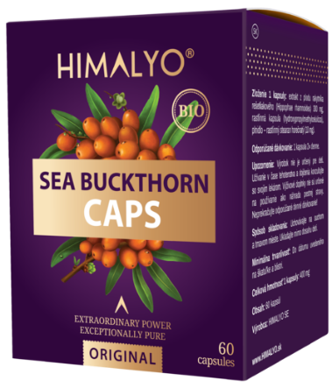

*Long Description:*

Plant (vegan) capsules enclose a gently prepared and super rich extract from the fruits of the Tibetan sea buckthorn. Processing takes place directly at the place of harvest. The powder is extracted in the form of cold drying, which allows the preservation of all nutrients from the fruits in their entire spectrum.

• Contributes to the proper functioning of the immune system

• Has a positive effect on heart health

• Supports the proper functioning of the digestive tract

• Has a positive effect on skin health

• Is an important antioxidant

*Ingredients:* BIO sea buckthorn extract 300mg, herbal capsule, filler - herbal magnesium stearate (10 mg). *60 capsules.*

*Categories:*Dietary Supplement. Immunity, Vitamin C, heart health, cardiovascular health, antioxidants, healing, natural stimulant, mental health, digestive tract, skin health, superfood, gluten free, vegan, raw, bio

*Short Description:*A natural extract from the alpine variety of Tibetan sea buckthorn to support immunity.

|  |  |
| --- | --- |
| *Logistics:* | |
| EAN | 8594193242047 |
| Content | 60 capsules |
| Weight (kg) | 0,07 |
| Height (mm) | 100 |
| Width (mm) | 80 |
| Depth (mm) | 63 |
| Pieces per carton | 8 |
| Pieces per pallet | 1152 |
| Customs code | 2106 90 92 |

**HIMALYO SEA BUCKTHORN 100% Caps BIO**

*Benefits:*

The Tibetan sea buckthorn is generally classified among the superfoods. This is not a fixed classification, but superfoods are generally understood as a nutritionally rich foods full of vitamins, minerals, fiber, antioxidants and nutrients of plant origin.

The name of this super berry comes from the ancient Greek word Hippophae, which means glittering horse. The ancient Greeks already discovered the beneficial effects of sea buckthorn, as horses grazing in areas with its high incidence were healthy, well built, and had shiny coats of hair.

**Ayurvedic and Tibetan Medicine**

The original sea buckthorn variety has been used in Ayurvedic and Tibetan medicine for thousands of years and is often called the plant of the future. Sea buckthorn fruits have always been widely used in the Himalayan region, especially to support immunity, for proper digestion and to suppress feelings of fatigue and exhaustion.

**Contemporary Medicine**

Modern medicine increasingly uses this beneficial plant, as sea buckthorn supports the immune system. In addition, regular use of sea buckthorn contributes to the normal function of the skin, cardiovascular system, digestive system and the prostate.

Sea buckthorn is widely used in cosmetics, where sea buckthorn oil, which is pressed either from the fruits or seeds of the sea buckthorn, is primarily used. A clinical study conducted at the University of Turku in Finland in 1999 found that sea buckthorn oil contributes to the good health of the skin and a healthy skin appearance within four months of its use as a dietary supplement. A Puredia case study in 2017 documented the effects of a two-week application of sea buckthorn oil on postoperative scars.

*Differentiation vs. common sea buckthorn products:*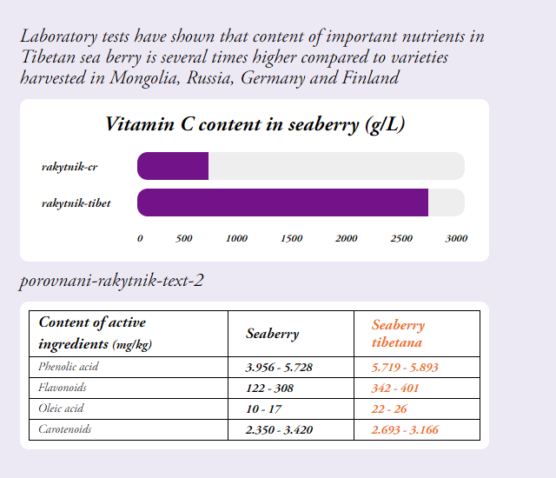

Tibet sea buckthorn – European sea buckthorn

1. Also other important nutrients had significantly higher values in Tibetan sea buckthorn when compared to European variety of sea buckthorn

--- a prosim zmenit v tabulce seaberry na sea buckthorn

*Warning:*Not intended for children under 3 years. Dietary supplements are not intended to be used as a substitute for a balanced diet. Do not exceed the recommended daily dosage! Store at room temperature away from direct sunlight. Keep out of reach of children.

*Recommended dosage:*1 capsule twice a day

*Main Claims for online marketing:*

* Natural support of immunity
* For strong immunity
* 100% Tibetan sea buckthorn with high content of Vitamin C

*Target distribution:*

*Online pharmacies, brick and mortar pharmacies, healthy food stores, organic/bio stores, drug stores – healthy diet*

*Target customer:*Women 35-50